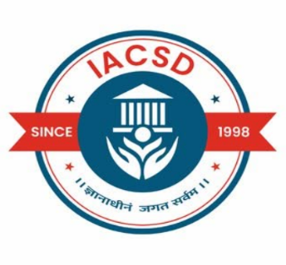
INSTITUTE FOR ADVANCED COMPUTING
AND
SOFTWARE DEVELOPMENT,
AKURDI, PUNE

DOCUMENTATION ON
“AUTOMATED DEVSECOPS CI/CD PIPELINE WITH SECURITY &
MONITORING”
PG-DITISS August 2025

SUBMITTED BY:
GROUP NO: 17
RITESH GURAV (258428)
TANMAY MUNGELWAR (258441)

MRS. SUSHMA HATTARKI MR. ANIL SHARMA
PROJECT GUIDE CENTRE CO-ORDINATOR

ABSTRACT

In today’s fast-paced software development environment, ensuring rapid delivery along with security and reliability has become a critical requirement. DevOps practices address this challenge by automating and integrating development and operations, while DevSecOps extends this approach by embedding security into every stage of the software development lifecycle. This projet presents the design and implementation of an end-to-end DevSecOps CI/CD pipeline that automates code integration, security analysis, containerization, deployment, and monitoring.
The pipeline is implemented using Jenkins for continuous integration and continuous deployment, with GitHub as the source code management platform. Security is integrated at multiple stages using SonarQube for static code analysis, OWASP Dependency-Check for identifying vulnerable dependencies, and Trivy for container image vulnerability scanning. The application is containerized using Docker and deployed on a Kubernetes cluster to ensure scalability, high availability, and zero-downtime deployments. Continuous monitoring and observability are achieved using Prometheus, Blackbox Exporter, and Grafana to track application performance, availability, and system health.
The proposed solution ensures early detection of security vulnerabilities, reduces manual intervention, and improves deployment reliability. This project demonstrates how DevSecOps practices can enhance software quality, security, and operational efficiency, making it suitable for modern enterprise and cloud-native application deployments.

TABLE OF CONTENTS

Sr. No. | Chapter Title | Page No.
1 | Introduction | 1
2 | Problem Statement | 3
3 | Literature Survey | 4
4 | Methodology | 5
5 | Requirement Specification | 7
6 | Working | 9
7 | Implementation | 11
8 | Advantages & Disadvantages | 17
9 | Conclusion | 19
10 | References | 20

Abbreviation |  | Full Form
- CI |  | Continuous Integration
- CD |  | Continuous Deployment / Continuous Delivery
- CI/CD |  | Continuous Integration and Continuous Deployment
- DevOps |  | Development and Operations
- DevSecOps |  | Development, Security, and Operations
- SDLC |  | Software Development Life Cycle
- SCM |  | Source Code Management
- SAST |  | Static Application Security Testing
- DAST |  | Dynamic Application Security Testing
- OWASP |  | Open Web Application Security Project
- CVE |  | Common Vulnerabilities and Exposures
- VCS |  | Version Control System
- API |  | Application Programming Interface
- YAML |  | Yet Another Markup Language
- CLI |  | Command Line Interface
- IDE |  | Integrated Development Environment
- VM |  | Virtual Machine
- OS |  | Operating System
- CPU |  | Central Processing Unit
- RAM |  | Random Access Memory
- HTTP |  | Hypertext Transfer Protocol
- HTTPS |  | Hypertext Transfer Protocol Secure
- SSL |  | Secure Sockets Layer
- TLS |  | Transport Layer Security
- SCA |  | Software Composition Analysis
- IaC |  | Infrastructure as Code
- RBAC |  | Role-Based Access Control
- DNS |  | Domain Name System
- IP |  | Internet Protocol
- TCP |  | Transmission Control Protocol
- UDP |  | User Datagram Protocol
- SLA |  | Service Level Agreement
- SLO |  | Service Level Objective
- SRE |  | Site Reliability Engineering
- KPI |  | Key Performance Indicator
- MTTR |  | Mean Time to Recovery
- HA |  | High Availability
- CI Tool |  | Jenkins
- SAST Tool |  | SonarQube
- Container |  | Docker
- Orchestrator |  | Kubernetes
- Monitoring Tool |  | Prometheus
- Visualization Tool |  | Grafana

- INTRODUCTION

In today’s rapidly evolving digital landscape, software applications are expected to be delivered at a faster pace while maintaining high standards of quality, security, and reliability. Traditional software development and deployment models often struggle to keep up with these demands due to manual processes, delayed testing, and reactive security measures. This has led to the adoption of DevOps, a cultural and technical approach that integrates software development (Dev) and IT operations (Ops) to enable continuous integration, continuous delivery, and faster time-to-market.
While DevOps improves speed and collaboration, security is frequently addressed at later stages of the software development lifecycle (SDLC), making applications vulnerable to security flaws, misconfigurations, and supply-chain attacks. To overcome this challenge, the concept of DevSecOps has emerged, which embeds security practices directly into the CI/CD pipeline. DevSecOps ensures that security is treated as a shared responsibility and is continuously enforced from code development to deployment and monitoring.
This project focuses on designing and implementing an End-to-End DevSecOps CI/CD Pipeline using industry-standard tools and technologies. The pipeline automates the process of source code integration, static code analysis, dependency vulnerability scanning, container image security, and deployment. Tools such as GitHub, Jenkins, SonarQube, OWASP Dependency-Check, and Trivy are integrated to provide continuous feedback on code quality and security vulnerabilities at every stage of the pipeline.
Containerization using Docker ensures application portability and consistency across environments, while Kubernetes is used for container orchestration and deployment, providing scalability and high availability. To ensure operational visibility and reliability, continuous monitoring is implemented using Prometheus, Blackbox Exporter, and Grafana, enabling real-time performance metrics, service availability checks, and visual dashboards.
By automating build, test, security scanning, deployment, and monitoring, this DevSecOps pipeline minimizes human error, reduces deployment risks, and enhances overall system reliability. The project demonstrates how modern organizations can adopt DevSecOps practices to deliver secure, scalable, and high-quality applications in a continuous and efficient manner.

LIST OF FIGURES

Figure No. | Figure Title / Description |  | Page No.
Figure 1 | Framework Diagram
Figure 2 | Working Architecture
Figure 3 | Jenkins Dashboard showing successful pipeline job
Figure 4 | Jenkins Pipeline Stage View
Figure 5 | SonarQube Quality Gate – PASSED
Figure 6 | Jenkins Workspace showing project files
Figure 7 | Jenkins Console Output showing successful deployment
Figure 8 | Sonar type Nexus Repository Dashboard
Figure 9 | Application running successfully on Kubernetes
Figure 10 | Jenkins Email Notification for successful build
Figure 11 | Prometheus Target Health Page
Figure 12 | Blackbox Exporter probing application endpoints
Figure 13 | Grafana Dashboard showing monitoring metrics

- PROBLEM STATEMENT

Traditional software development and deployment processes often lack automation, integrated security, and continuous monitoring. Development, operations, and security activities are typically performed in isolation, leading to delayed releases, configuration inconsistencies, and late detection of security vulnerabilities. Manual deployment practices increase the risk of errors and are not suitable for scalable, cloud-native environments.
Additionally, the absence of real-time monitoring makes it difficult to quickly identify application failures and performance issues in production. Therefore, there is a need for an automated end-to-end DevSecOps CI/CD pipeline that integrates continuous integration, security scanning, containerized deployment, and continuous monitoring to ensure secure, reliable, and efficient software delivery.

- LITERATURE SURVEY

Several studies and industry practices highlight the growing adoption of DevOps and DevSecOps methodologies to improve software delivery speed, reliability, and security. Research indicates that traditional CI/CD pipelines improve automation but often fail to address security concerns effectively when security testing is introduced only at later stages of development. This gap has led to the evolution of DevSecOps, where security is integrated throughout the software development lifecycle.
Existing literature emphasizes the use of Jenkins as a widely adopted CI/CD automation tool due to its extensibility and plugin support. Docker has become a standard for containerization, providing application portability and environment consistency, while Kubernetes is extensively used for container orchestration, enabling scalability, high availability, and self-healing deployments. Studies also highlight the effectiveness of static code analysis tools such as SonarQube and dependency vulnerability scanners like OWASP Dependency-Check in identifying code quality issues and third-party risks at early stages.
Monitoring and observability tools such as Prometheus and Grafana are commonly recommended in cloud-native environments to provide real-time insights into system performance and availability. The reviewed literature concludes that integrating CI/CD automation with security scanning, container orchestration, and continuous monitoring significantly enhances software quality, reduces deployment risks, and improves operational efficiency in modern enterprise environments.

- METHODOLOGY
4.1 SYSTEM ARCHITECTURE
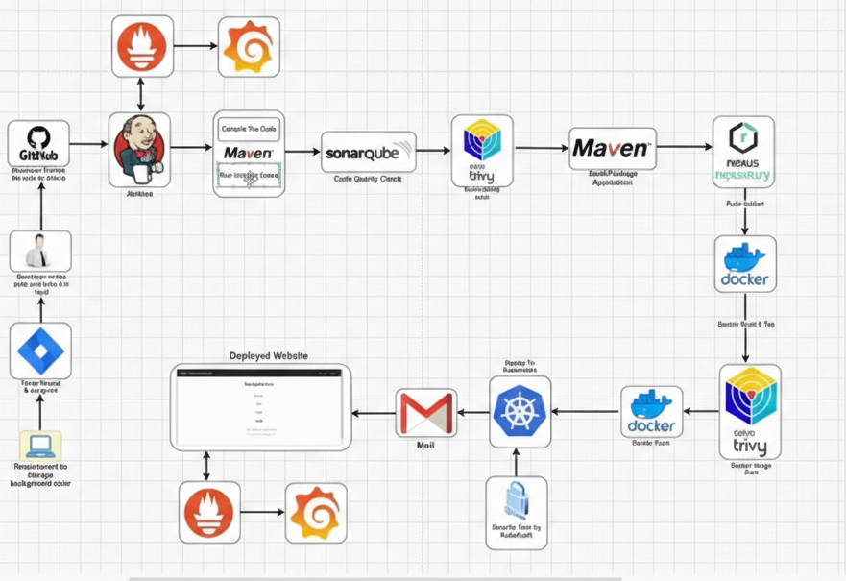
Figure 1: Framework Diagram

The proposed system follows an end-to-end DevSecOps CI/CD methodology that integrates development, security, deployment, and monitoring in a continuous and automated manner. The methodology is implemented using Jenkins, GitHub, Maven, SonarQube, Nexus, Docker, Kubernetes, Trivy, Prometheus, Grafana, and notification mechanisms.
- Code Development and Version Control
The development process begins with the developer writing application code on a local system. The source code is then pushed to a centralized GitHub repository, which acts as the source code management (SCM) system. Any change in the repository triggers the CI/CD pipeline.
- Continuous Integration using Jenkins
Jenkins is configured to automatically pull the latest code from GitHub whenever a commit occurs. Jenkins acts as the orchestration engine, managing all subsequent stages of the pipeline.
- Build and Compilation
The application is built using Maven, which compiles the source code and resolves project dependencies. This step ensures that the application is syntactically correct and ready for further quality and security checks.

- Static Code Analysis
After a successful build, SonarQube is used to perform static code analysis. It checks the source code for bugs, code smells, and security vulnerabilities. Quality gates are enforced to ensure that only code meeting predefined standards proceeds further in the pipeline.
- Dependency and Artifact Management
Once the code passes quality checks, Maven packages the application, and the generated artifacts are stored in the Nexus Repository. Nexus acts as an artifact repository, ensuring secure storage and version control of build outputs.
- Containerization and Image Creation
The application artifact is containerized using Docker. A Docker image is created to ensure consistency across development, testing, and production environments.
- Container Image Security Scanning
Trivy is integrated to scan the Docker image for known vulnerabilities, misconfigurations, and exposed secrets. Only vulnerability-free images are allowed to move to the deployment stage.
- Continuous Deployment using Kubernetes
The secure Docker image is deployed to a Kubernetes cluster using deployment and service manifests. Kubernetes provides container orchestration, scalability, load balancing, and high availability for the application.
- Notification and Feedback Mechanism
Jenkins is configured to send email notifications to developers after each pipeline execution. These notifications provide build, deployment, and security scan status, enabling quick feedback and issue resolution.
- Monitoring and Observability
Prometheus is used to collect metrics from the application and Kubernetes cluster. Blackbox Exporter monitors application endpoint availability, while Grafana visualizes performance metrics such as CPU usage, memory utilization, response time, and uptime through interactive dashboards.
- Continuous Monitoring of Deployed Application
The deployed website is continuously monitored to ensure availability, performance, and reliability. Any anomalies or failures can be quickly detected and addressed using the monitoring dashboards.

- REQUIREMENT SPECIFICATION

The successful implementation of the End-to-End DevSecOps CI/CD Pipeline requires appropriate hardware, software, and network resources. The following specifications define the minimum and recommended requirements for deploying and operating the system efficiently.

HARDWARE REQUIREMENTS
Component |  |  |  |  | Specification
Processor |  |  |  |  | Multi-core CPU (2 vCPU or higher)
RAM |  |  |  |  | Minimum 4 GB (8 GB recommended)
Storage |  |  |  |  | Minimum 20 GB disk space
Infrastructure |  |  |  |  | Physical Server or Cloud VM (AWS EC2)
Architecture |  |  |  |  | 64-bit System

SOFTWARE REQUIREMENTS
Category |  |  |  |  | Tools / Technologies
Operating System |  |  |  |  | Linux (Ubuntu / Debian)
Version Control |  |  |  |  | Git, GitHub
CI/CD Tool |  |  |  |  | Jenkins
Build Tool |  |  |  |  | Maven
Code Quality Tool |  |  |  |  | SonarQube
Artifact Repository |  |  |  |  | Nexus
Containerization |  |  |  |  | Docker
Orchestration |  |  |  |  | Kubernetes
Security Tools |  |  |  |  | Trivy, OWASP Dependency-Check
Monitoring Tools |  |  |  |  | Prometheus, Blackbox Exporter, Grafana
Notification |  |  |  |  | Email (SMTP)

- WORKING

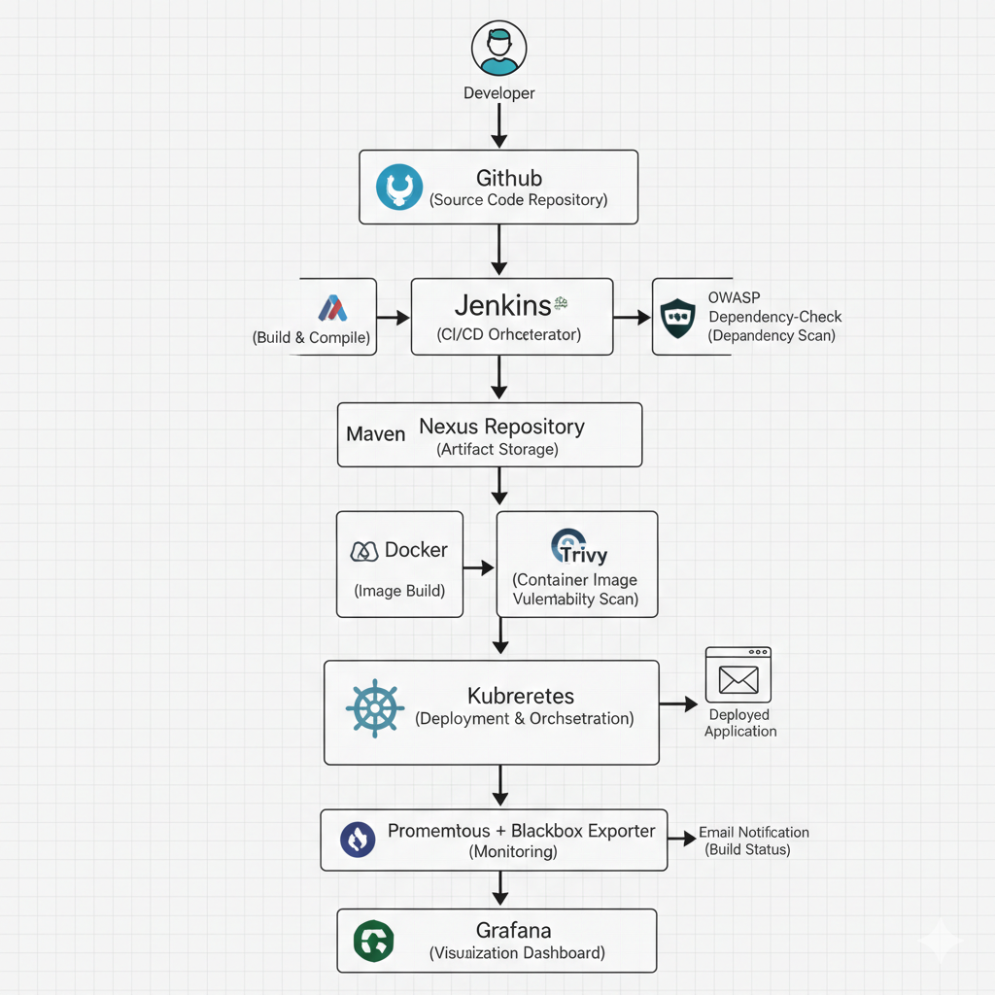
Figure 2 : Working Architecture

PHASES OF WORKING
Phase 1: Code Development & Version Control
The developer writes application code and pushes it to the GitHub repository. GitHub acts as the centralized source code management system and serves as the trigger point for the CI/CD pipeline.

Phase 2: Continuous Integration
Jenkins automatically pulls the latest code from GitHub. It controls and automates all stages of the pipeline, ensuring consistent execution.

Phase 3: Build & Compilation
Maven is used to compile the source code, resolve dependencies, and generate build artifacts. This ensures the application is ready for quality and security analysis.

Phase 4: Code Quality & Security Analysis
SonarQube performs static code analysis to detect bugs, vulnerabilities, and code smells. OWASP Dependency-Check scans third-party libraries for known vulnerabilities.

Phase 5: Artifact Management
The validated build artifact is stored in the Nexus Repository. Nexus ensures versioning, secure storage, and easy retrieval of artifacts.

Phase 6: Containerization
Docker is used to build a container image from the application artifact. Containerization ensures environment consistency across all stages.

Phase 7: Container Security Scanning
Trivy scans the Docker image for known vulnerabilities, exposed secrets, and misconfigurations. Only secure images are allowed to proceed.

Phase 8: Continuous Deployment
The Docker image is deployed to a Kubernetes cluster using deployment and service manifests. Kubernetes provides scalability, load balancing, and high availability.

Phase 9: Notification
Jenkins sends email notifications to developers indicating the success or failure of the pipeline execution.

Phase 10: Monitoring & Observability
Prometheus collects system and application metrics, Blackbox Exporter checks application availability, and Grafana visualizes metrics using dashboards for continuous monitoring.

- IMPLEMENTATION

The implementation of the End-to-End DevSecOps CI/CD Pipeline is carried out in a systematic and stage-wise manner to ensure automation, security, scalability, and continuous monitoring. Each tool is configured to integrate seamlessly with the pipeline, enabling secure and reliable application delivery.

The implementation is divided into multiple stages as follows.

Stage 1: Network Environment Setup (AWS EC2)
AWS EC2 instances are created for Kubernetes cluster, CI/CD tools, and monitoring stack using Ubuntu OS.
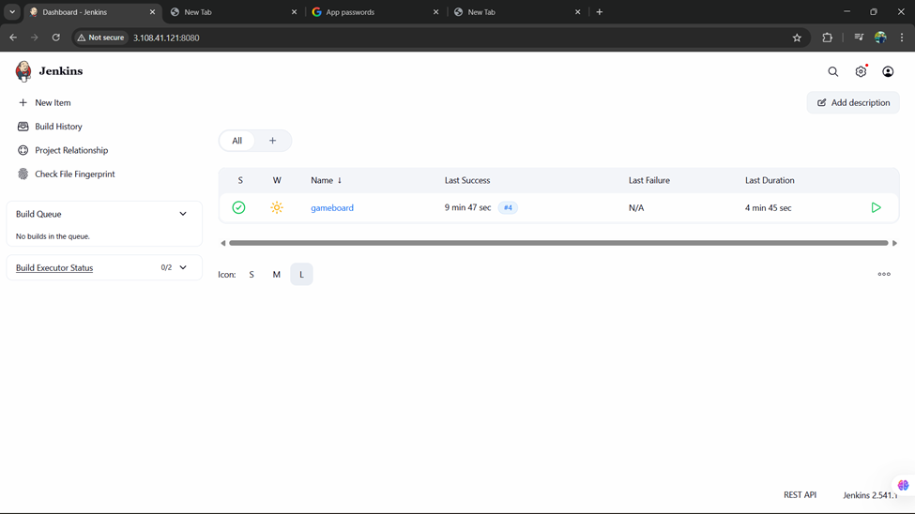
Figure 3: Jenkins Dashboard showing successful pipeline job

Stage 2: Kubernetes Cluster Setup
A multi-node Kubernetes cluster is created using kubeadm and verified using kubectl get nodes.
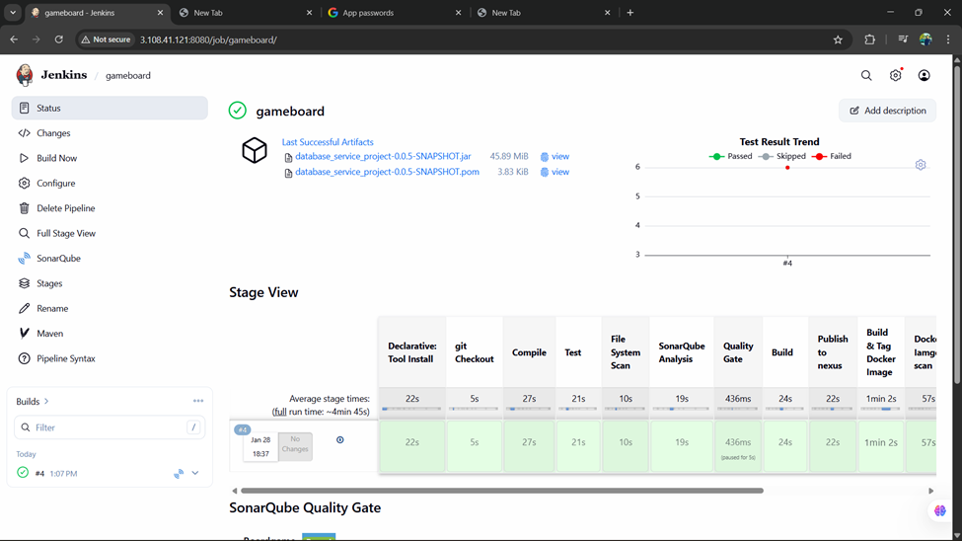
Figure 4: Jenkins pipeline stage view

Stage 3: CI/CD Tool Setup
Jenkins, SonarQube, and Nexus are installed and configured on separate EC2 instances.
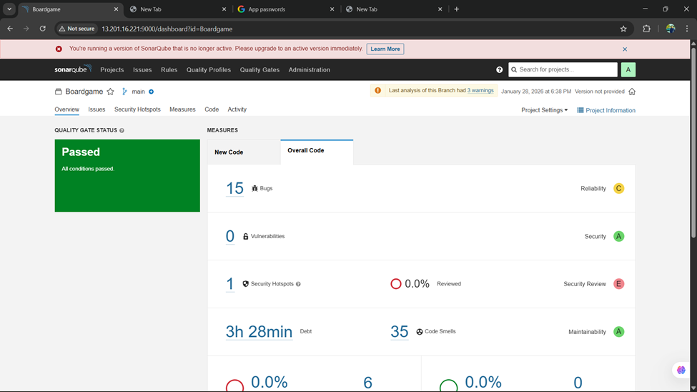
Figure 5: SonarQube Quality Gate – PASSED

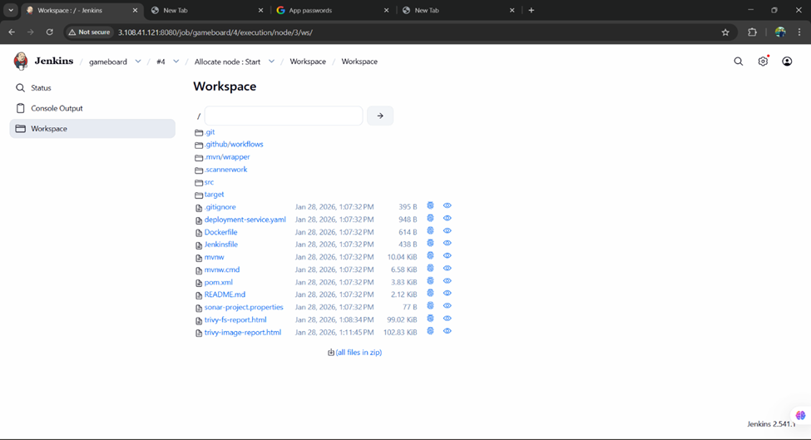
Figure 6: Jenkins workspace showing project files
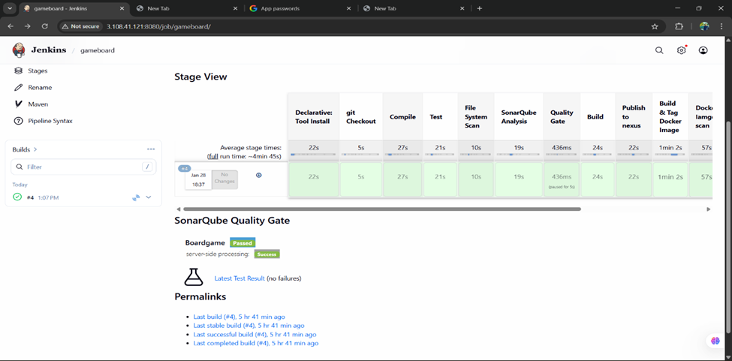
Figure 7: Jenkins console output showing successful deployment
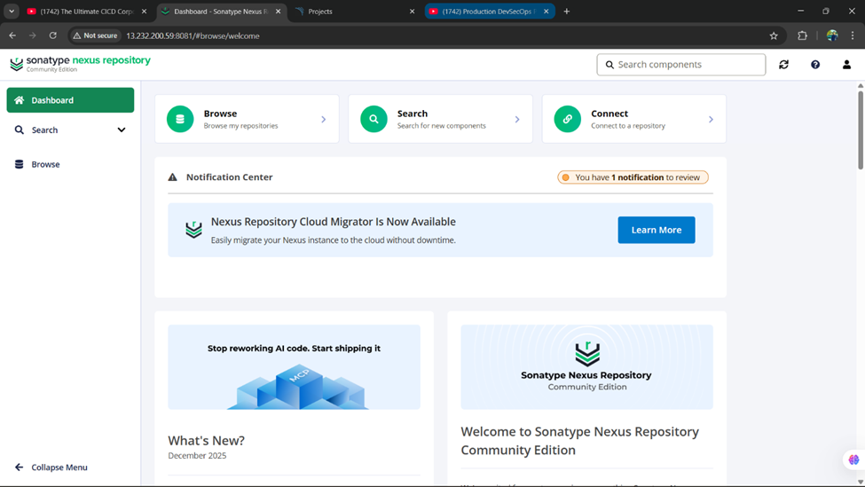
Figure 8: Sonatype Nexus repository dashboard

Stage 4: Application Deployment Verification
The application is successfully deployed on Kubernetes and accessed via service external IP.
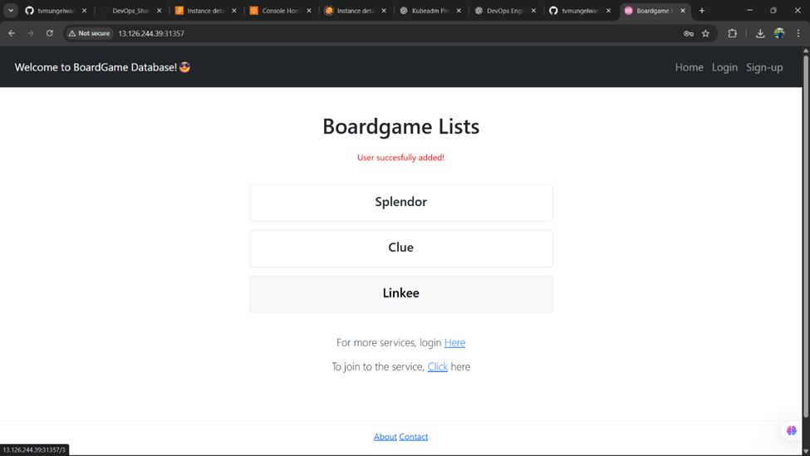
Figure 9: Application running successfully

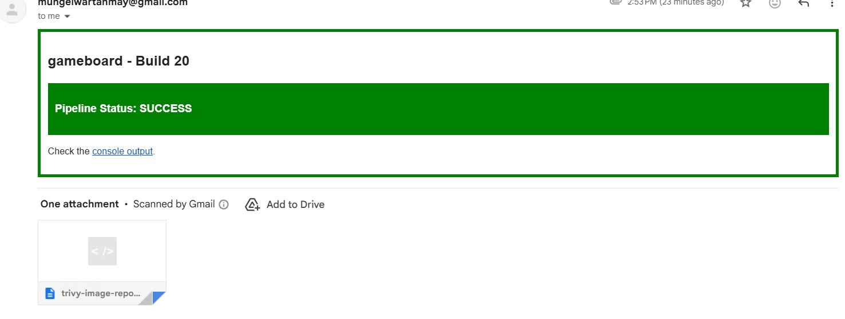
Figure 10: Jenkins email notification for successful build

Stage 5: Monitoring Setup
Monitoring is implemented using Prometheus, Blackbox Exporter, and Grafana on a separate EC2 instance.
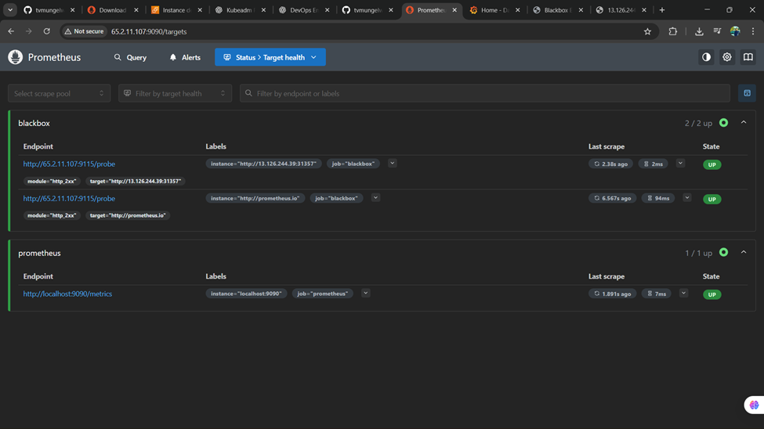
Figure 11: Prometheus target health page
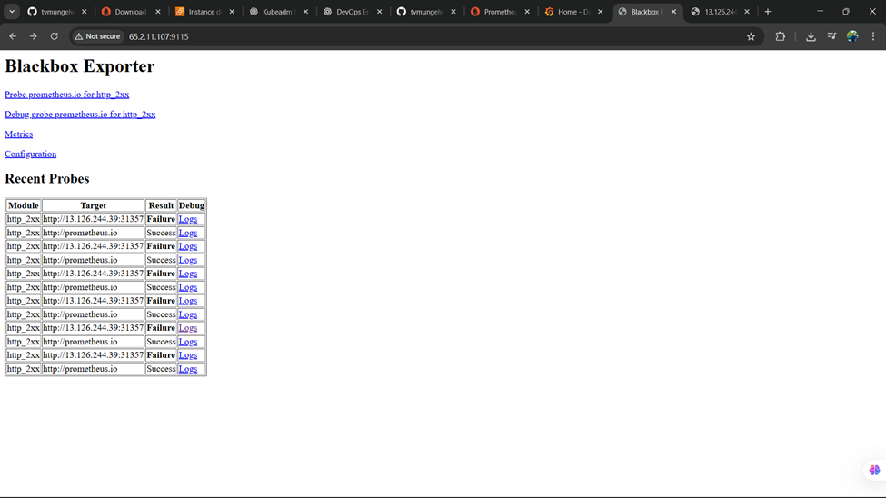
Figure 12: Blackbox exporter probing endpoints

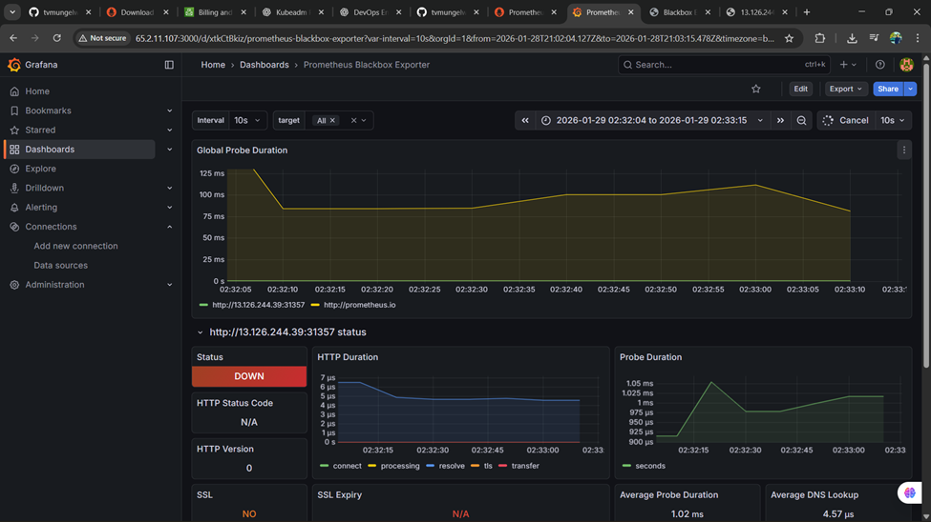
Figure 13: Grafana dashboard showing monitoring metrics

- ADVANTAGES & DISADVANTAGES

Advantages
- Automated Software Delivery
The CI/CD pipeline automates build, testing, security scanning, and deployment, reducing manual intervention and human errors.
- Early Security Detection
Integration of SonarQube, OWASP Dependency-Check, and Trivy enables early identification of code, dependency, and container vulnerabilities.
- Improved Code Quality
Static code analysis ensures adherence to coding standards and improves maintainability.
- Scalability and High Availability
Kubernetes provides automatic scaling, load balancing, and self-healing capabilities.
- Faster Release Cycles
Automation significantly reduces deployment time and improves time-to-market.
- Continuous Monitoring
Prometheus and Grafana provide real-time visibility into application performance and system health.
- Consistency Across Environments
Docker ensures consistent application behavior across development, testing, and production environments.

Disadvantages
- Initial Setup Complexity
Setting up and integrating multiple tools requires significant configuration effort and expertise.
- High Resource Consumption
CI/CD tools, Kubernetes, and monitoring stacks require considerable system resources.
- Learning Curve
DevSecOps tools and practices demand skilled professionals and continuous learning.
- Maintenance Overhead
Regular updates, security patches, and monitoring tool maintenance are required.
- Tool Dependency
Heavy reliance on multiple third-party tools can increase operational complexity.

- CONCLUSION

This project successfully demonstrates the design and implementation of an end-to-end DevSecOps CI/CD pipeline that integrates automation, security, containerization, deployment, and monitoring into a unified workflow. By incorporating security practices at every stage of the pipeline, the solution ensures early detection of vulnerabilities and improves overall software quality and reliability.
The use of Jenkins for CI/CD automation, GitHub for source code management, Docker for containerization, and Kubernetes for orchestration enables consistent and scalable application deployment. Security tools such as SonarQube, OWASP Dependency-Check, and Trivy enhance the security posture by identifying code-level, dependency-level, and container-level vulnerabilities. Continuous monitoring using Prometheus, Blackbox Exporter, and Grafana provides real-time insights into application performance and availability.
Overall, the implemented DevSecOps pipeline reduces manual effort, minimizes deployment risks, and accelerates software delivery. This project reflects modern industry best practices and demonstrates how DevSecOps can be effectively applied to build secure, reliable, and scalable cloud-native applications.

- REFERENCES

- Jenkins Documentation – Continuous Integration and Continuous Delivery
https://www.jenkins.io/doc/
- Docker Documentation – Containerization and Image Management
https://docs.docker.com/
- Kubernetes Documentation – Container Orchestration Platform
https://kubernetes.io/docs/
- SonarQube Documentation – Static Code Analysis and Code Quality
https://docs.sonarsource.com/
- OWASP Foundation – OWASP Dependency-Check Tool
https://owasp.org/www-project-dependency-check/
- Trivy Documentation – Container Image Vulnerability Scanner
https://aquasecurity.github.io/trivy/
- Prometheus Documentation – Monitoring and Alerting Toolkit
https://prometheus.io/docs/
- Grafana Documentation – Metrics Visualization and Dashboards
https://grafana.com/docs/
- Nexus Repository Documentation – Artifact Repository Management
https://help.sonatype.com/
- GitHub Documentation – Source Code Management and Collaboration
https://docs.github.com/

